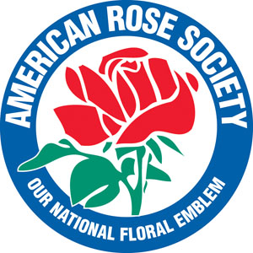
NEWS RELEASE

American Rose Society
P. O. Box 30,000 Shreveport, LA 71130-0030
8877 Jefferson Paige Road Shreveport, LA 71119-8817
Phone: 318-938-5402 Fax: 318-938-5405 www.rose.org

FOR IMMEDIATE RELEASE
August 16, 2019
Contact: Jon Corkern, executivedirector@rose.org

2019 GREEN THUMB SEMINAR
The Joys and Trials of Gardening

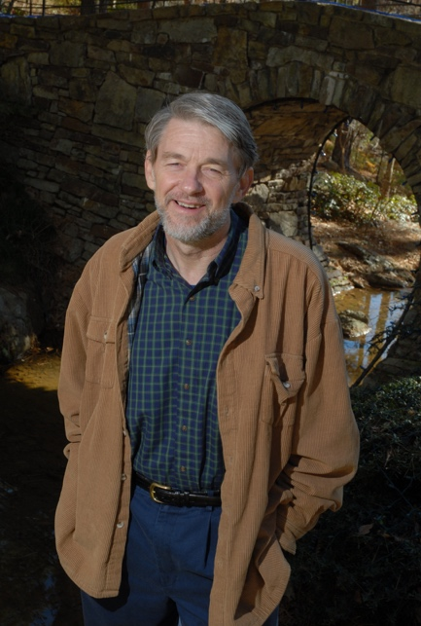
SHREVEPORT, LA - The American Rose Center invites you to our final 2019 Green Thumb
Educational Seminar on Saturday, September 7, 2019.

Date: September 7, 2019
Place: Klima Rose Hall, America’s Rose Garden, 8877 Jefferson Paige Road
Time: 9:00 a.m. – 11 a.m.
Cost: Seminar is FREE and open to the public.

Schedule:
9:00 a.m. – 11 a.m. Bob Byers, Director, Fort Worth Botanic Garden
Bob will speak on the joys and trials of spending every day in the beauty of the Fort Worth Botanic Garden. Prior to his tenure at Fort Worth, Byers was a 20-year director at Garvan Woodland Gardens at Hot Springs, AR. He will share his experience in developing that garden in its natural setting, which is not unlike the American Rose Center in its “personality” of peace and tranquility. It has been said, he will help us “see the forest for the trees.”

Bob holds a Master of Landscape Architecture from Louisiana State University. He worked professionally at Apostle Islands Nat. Lakeshore, WI, and for design firms in Jacksonville, FL., Birmingham, AL, and Fayetteville, AR. During his tenure at Garvan Woodland Gardens he worked with staff and volunteers to build plant collections to more than 3,500 different varieties.

Bob has published articles for Arkansas Gardener, The Public Garden and American Nurseryman. He has presented programs at state and international Master Gardener Conferences, the AHS Children’s Gardening Symposium, and the American Public Garden Association.

Since April 2015 he has served as the Director of the Fort Worth Botanic Garden, where he works with 60 dedicated employees, more than 1,000 volunteers, and several active support groups. He is enjoying learning the large and varied flora of Texas and speaking on gardening and conservation topics.

The American Rose Center, located at 8877 Jefferson Paige Road in Shreveport, LA, is open through Oct. 31, 2019: Monday through Saturday 9 a.m. to 5 p.m. and Sunday from 1 p.m. to 5 p.m. END

