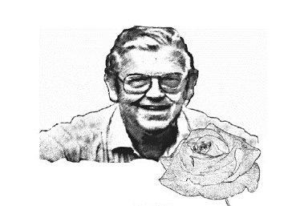
THE GUY BLAKE HEDRICK JR. AWARD

Established in memory of Guy Blake Hedrick Jr., to recognize outstanding rose exhibitors who display the highest levels of excellence, integrity and respect for the ideals of showing roses, the Guy Blake Hedrick Jr. Award is intended as a lifelong achievement award for an exhibitor who has been a successful national, district and local exhibitor, and also a model in sharing his/her knowledge in growing championship roses. Nominees for the award shall be members of the ARS, and nominations may be made by any person. The ARS
Horticultural Exhibitors’ Committee will select the Blake Hedrick Award recipient. Acts worthy of this
recognition include:
- Sustained success in showing roses at the national, district and local levels for a decade or longer by an individual or team who has consistently exhibited rose show entries of the highest caliber with integrity and spirit for the ideals of the ARS.
- Sustained lifetime achievement by an individual in devoting and focusing his or her educational talents and expertise to promoting the art of exhibition of the rose.
- Significant and sustained acts of achievement by an individual in organizing and overseeing the conduct of successful rose shows at all levels.

2003 Evan T. ‘Slats’ Wathen
2004 Jeff Stage
2005 Drs. Satish & Vijaya Prabhu
2006 Harold & Jean Baker
2007 Robert B. Martin, Jr.
2008 Dr. Thomas Cairns & Luis Desamero
2009 John & Donna Hefner
2010 Bob & Sandy Lundberg
2011 Don & Paula Ballin
2012 Larry & Doris Meyer
2013 Bob & Doris House
2014 Dale & Elaine Martin
2015 John Mattia
2016 Andy Plasz
2017 Eddie & Minnie Garcia
2018 Dennis Konsmo
2019 Louise Coleman
2020 Bill & Kathy Kozemchak
2021 Kitty & Bob Belendez
2022 John & Cherilynn Smith

Current 2022

